**Script Screenshot:**

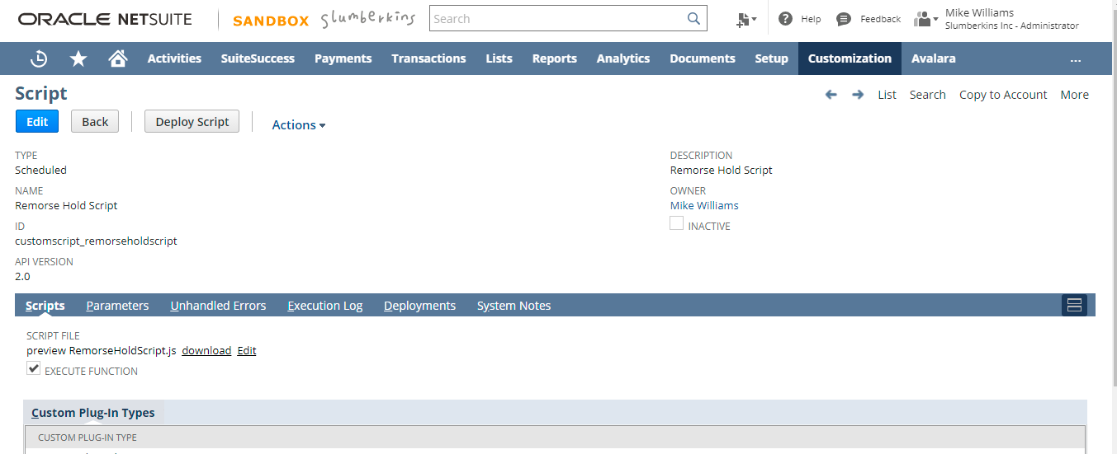

**Script Criteria:**

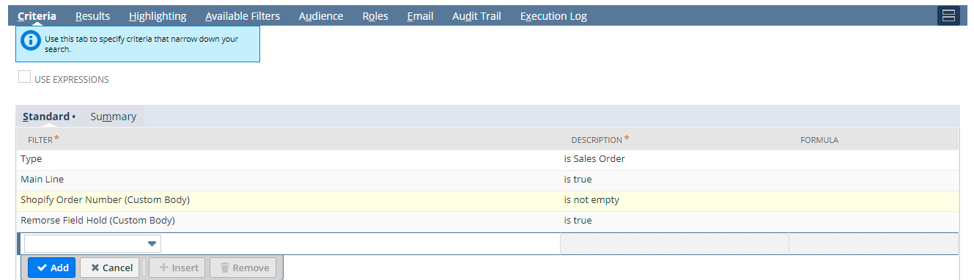

**Search Results:**

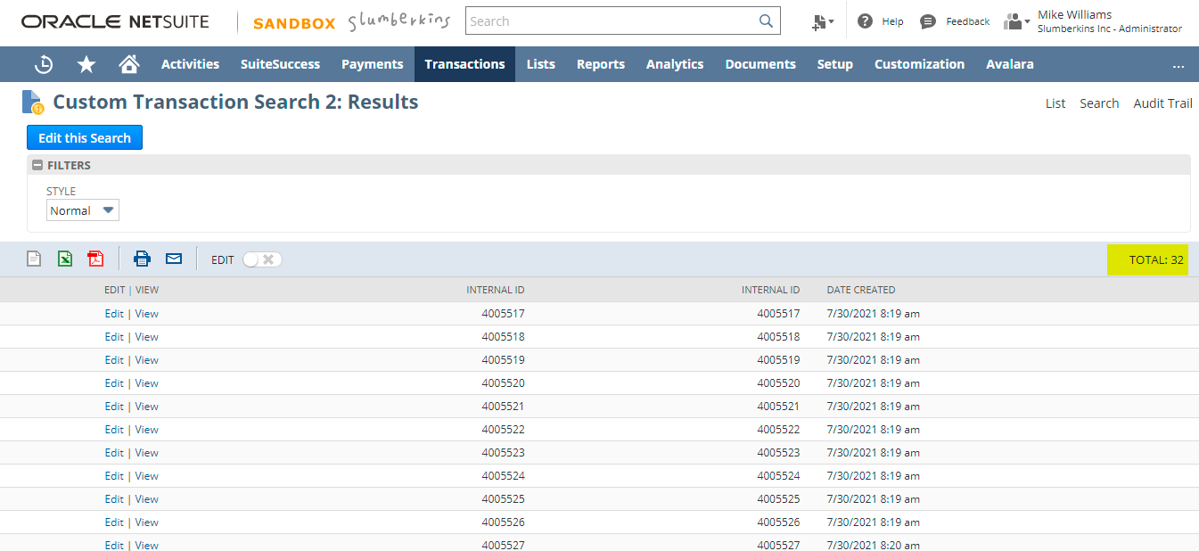

I am running the script by keeping a condition to run for only for the first result. That is 4005517. This is for testing purpose only. Later I have removed the condition. Click on the save and execute button.

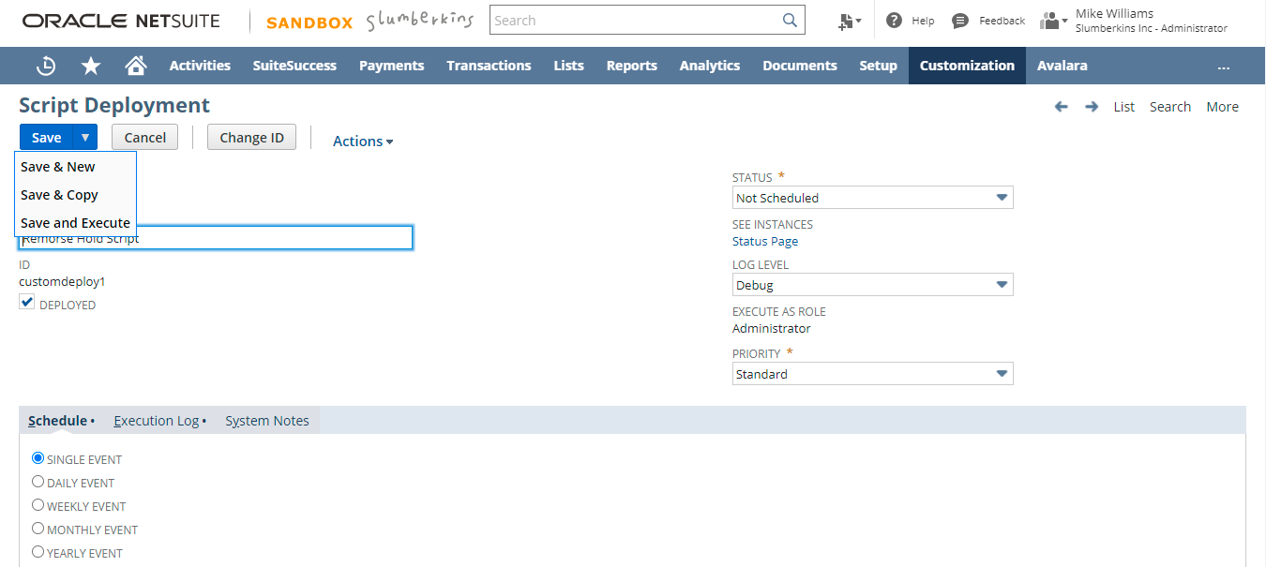

**Script Status:**

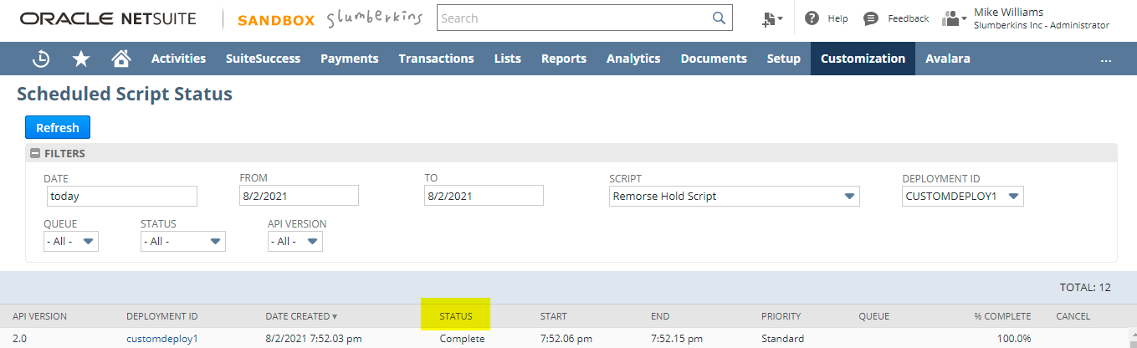

**Before Run:**

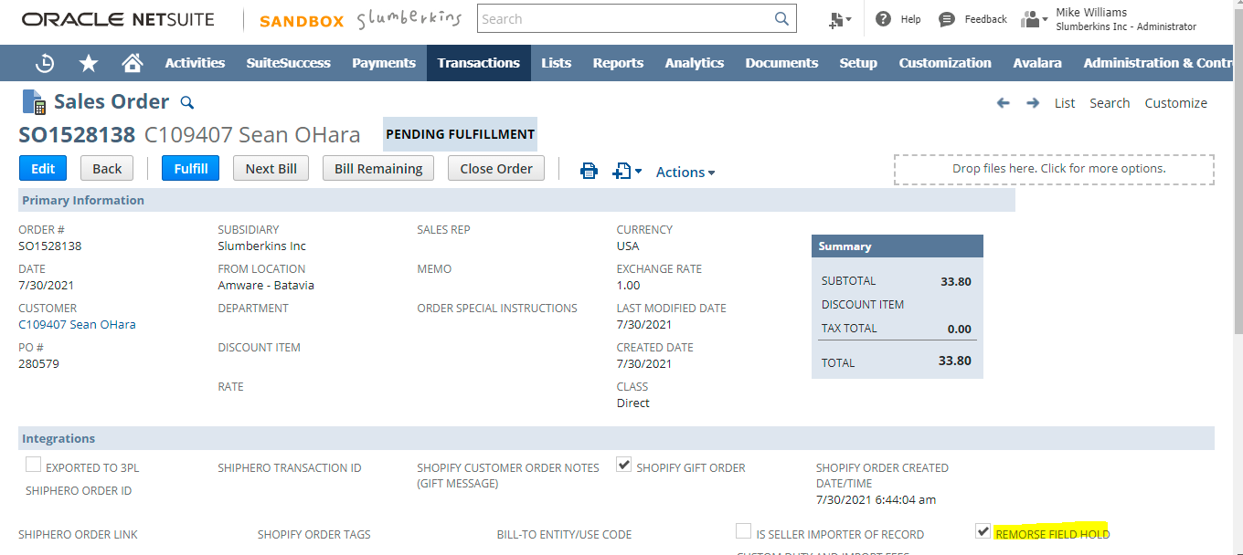

**After Run:**

